常用技能：[http://www.cnblogs.com/dunitian/p/4822808.html#skill](http://www.cnblogs.com/dunitian/p/4822808.html" \l "skill" \t "_blank)

逆天博客：[http://dnt.dkil.net](http://dnt.dkil.net/" \t "_blank)

逆天通用水印支持Winform，WPF，Web，WP，Win10。支持位置选择（9个位置 ==》[X]）：[http://www.cnblogs.com/dunitian/p/4939369.html](http://www.cnblogs.com/dunitian/p/4939369.html" \t "_blank)

本次添加了一些新东西，比如剪贴板之类的水印操作。完善了部分功能（比如文件过滤，非Bitmap图片的处理，以及一些其他玩意等待你的发现）

先贴下新增的效果：

单个图片水印



多文件直接水印



网页图片批量转



word文档图片批量转



剪贴板图片水印



自动化配置



上篇重复的技术点我就不继续说了，这次主要贴一下剪贴板系列的code

|  |
| --- |
| using System;  using System.Collections.Generic;  using System.Drawing;  using System.Drawing.Imaging;  using System.IO;  using System.Net;  using System.Text;  using System.Text.RegularExpressions;  using System.Windows;    namespace WaterMarkAPP.Common  {      public class ClipboardHelper      {          /// <summary>          /// 获取剪贴板里的图片          /// </summary>          /// <returns></returns>          public static IEnumerable<string> GetImagePathList()          {              var imgPathList = new List<string>();              var data = Clipboard.GetDataObject();              var formats = data.GetFormats();              //二进制存储 (存储在剪贴板的截图|画画图内的图片)              if (data.GetDataPresent(DataFormats.Dib, true))              {                  var imgSorce = Clipboard.GetImage();                  Bitmap bmp = new Bitmap(imgSorce.PixelWidth, imgSorce.PixelHeight, PixelFormat.Format32bppPArgb);                  BitmapData bmpdata = bmp.LockBits(new Rectangle(System.Drawing.Point.Empty, bmp.Size), ImageLockMode.WriteOnly, PixelFormat.Format32bppPArgb);                  imgSorce.CopyPixels(Int32Rect.Empty, bmpdata.Scan0, bmpdata.Height \* bmpdata.Stride, bmpdata.Stride);                  bmp.UnlockBits(bmpdata);                  CreateDirectory();                  string filePath = string.Format(@"Images\{0}.png", Guid.NewGuid());                  bmp.Save(filePath, ImageFormat.Png);                  imgPathList.Add(filePath);              }              //图片文件              if (data.GetDataPresent(DataFormats.FileDrop, true))              {                  string[] objs = (string[])data.GetData(DataFormats.FileDrop, true);                  if (objs != null)                  {                      for (int i = 0; i < objs.Length; i++)                      {                          imgPathList.Add(objs[i]);                      }                  }              }              //剪贴板内单文件              if (data.GetDataPresent(DataFormats.Bitmap, true))              {                  string filePath = SaveImg(data.GetData(DataFormats.Bitmap, true) as Bitmap);                  if (filePath != null) { imgPathList.Add(filePath); }              }              //HTML页面里面的图片（网页 + word）              if (data.GetDataPresent(DataFormats.Html, true))              {                  var obj = data.GetData(DataFormats.Html, true);                  if (obj != null)                  {                      string dataStr = obj.ToString();                      imgPathList.AddRange(DownloadImg(dataStr));                  }                }              return imgPathList;          }            /// <summary>          /// 保存图片，返回图片地址          /// </summary>          /// <param name="bitmap"></param>          /// <returns></returns>          private static string SaveImg(Bitmap bitmap)          {              if (bitmap == null) { return null; }              CreateDirectory();              string filePath = string.Format(@"Images\{0}.png", Guid.NewGuid());              try { bitmap.Save(filePath, ImageFormat.Png); return filePath; }              catch (Exception ex) { DNTLog(ex); return null; }          }            /// <summary>          /// 批量下载图片          /// </summary>          /// <param name="dataStr">页面字符串</param>          /// <param name="i">成功条数</param>          /// <returns></returns>          private static IEnumerable<string> DownloadImg(string dataStr)          {              var imgPathList = new List<string>();              var collection = Regex.Matches(dataStr, @"<img([^>]\*)\s\*src=('|\"")([^'\""]+)('|\"")", RegexOptions.ECMAScript);              WebClient webClient = new WebClient();              foreach (Match item in collection)              {                  string imgPath = item.Groups[3].Value;                  try                  {                      CreateDirectory();                      string filePath = string.Format(@"Images\{0}", Path.GetFileName(imgPath));                      webClient.DownloadFile(item.Groups[3].Value, filePath);//剪贴板的图片没有相对路径                      imgPathList.Add(string.Format(@"{0}\{1}", Directory.GetCurrentDirectory(), filePath));                  }                  catch (Exception ex) { DNTLog(ex); }              }              return imgPathList;          }            private static void DNTLog(Exception ex)          {              File.WriteAllText("log.dnt", ex.ToString(), Encoding.UTF8);          }            /// <summary>          /// 创建文件夹          /// </summary>          private static void CreateDirectory()          {              if (!Directory.Exists("Images"))              {                  Directory.CreateDirectory("Images");              }          }      }  } |

水印帮助类注意点

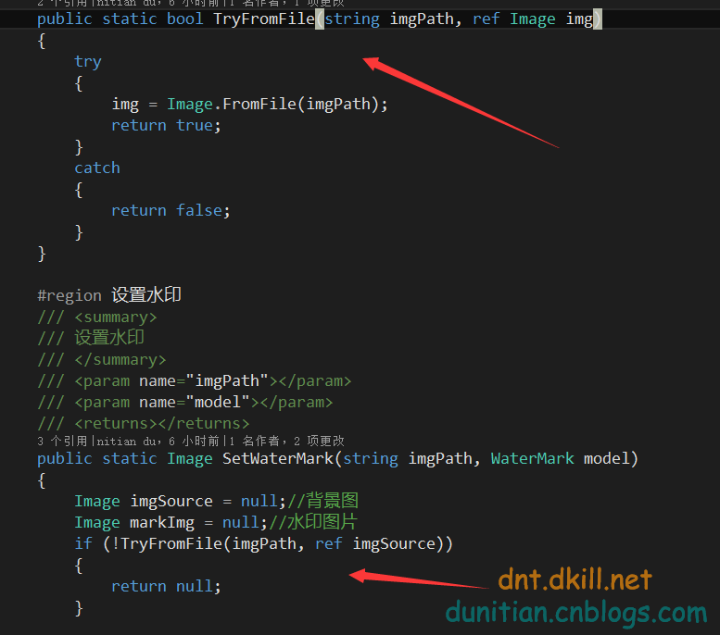

|  |
| --- |
| using System.Drawing;  using System.Drawing.Drawing2D;  using System.Drawing.Imaging;  using System.Text;  using WaterMarkAPP.Enums;  using WaterMarkAPP.Model;    namespace WaterMarkAPP.Common  {        /// <summary>      /// 水印帮助类      /// </summary>      public class WaterMarkHelper      {          public static bool TryFromFile(string imgPath, ref Image img)          {              try              {                  img = Image.FromFile(imgPath);                  return true;              }              catch              {                  return false;              }          }            #region 设置水印          /// <summary>          /// 设置水印          /// </summary>          /// <param name="imgPath"></param>          /// <param name="model"></param>          /// <returns></returns>          public static Image SetWaterMark(string imgPath, WaterMark model)          {              Image imgSource = null;//背景图              Image markImg = null;//水印图片              if (!TryFromFile(imgPath, ref imgSource))              {                  return null;              }                //水印检验（文字，图片[路径下是否存在图片]）              #region 水印校验+水印处理              if (model == null) { return null; }              if (!System.IO.File.Exists(imgPath)) { return null; }//看看原图是否存在              //根据水印类型校验+水印处理              switch (model.WaterMarkType)              {                  case WaterMarkTypeEnum.Text:                      if (string.IsNullOrEmpty(model.Text))                      {                          return null;                      }                      else                      {                          markImg = TextToImager(model);//水印处理-如果是文字就转换成图片                      }                      break;                  case WaterMarkTypeEnum.Image:                      if (!System.IO.File.Exists(model.ImgPath))                      {                          return null;                      }                      else                      {                          if (!TryFromFile(model.ImgPath, ref markImg))//获得水印图像                          {                              return imgSource;                          }                      }                      break;                  case WaterMarkTypeEnum.NoneMark:                      return imgSource;              }              #endregion                #region 创建颜色矩阵              //创建颜色矩阵              float[][] ptsArray ={                                   new float[] {1, 0, 0, 0, 0},                                   new float[] {0, 1, 0, 0, 0},                                   new float[] {0, 0, 1, 0, 0},                                   new float[] {0, 0, 0, model.Transparency, 0}, //注意：0.0f为完全透明，1.0f为完全不透明                                   new float[] {0, 0, 0, 0, 1}};              ColorMatrix colorMatrix = new ColorMatrix(ptsArray);              //新建一个Image属性              ImageAttributes imageAttributes = new ImageAttributes();              //将颜色矩阵添加到属性              imageAttributes.SetColorMatrix(colorMatrix, ColorMatrixFlag.Default, ColorAdjustType.Default);              #endregion                //原图格式检验+水印              #region 原图格式检验+水印              //判断是否是索引图像格式              if (imgSource.PixelFormat == PixelFormat.Format1bppIndexed || imgSource.PixelFormat == PixelFormat.Format4bppIndexed || imgSource.PixelFormat == PixelFormat.Format8bppIndexed)              {                  #region 索引图片,转成位图再加图片                  //转成位图,这步很重要                  Bitmap bitmap = new Bitmap(imgSource.Width, imgSource.Height);                  Graphics graphic = Graphics.FromImage(bitmap);                    #region 缩放处理                  //如果原图小于水印图片 等比缩放水印图                  if (markImg.Width >= imgSource.Width || markImg.Height >= imgSource.Height)                  {                      markImg = ImageShrink(imgSource, markImg);                  }                  #endregion                    #region 水印位置                  //水印位置                  int x;                  int y;                  WaterMarkLocations(model, imgSource, markImg, out x, out y);                  #endregion                    //将原图画在位图上                  graphic.DrawImage(imgSource, new Point(0, 0));                    //将水印加在位图上                  graphic.DrawImage(markImg, new Rectangle(x, y, markImg.Width, markImg.Height), 0, 0, markImg.Width, markImg.Height, GraphicsUnit.Pixel, imageAttributes);                    graphic.Dispose();                  return bitmap;                  #endregion              }              else              {                  #region 非索引图片,直接在上面加上水印                  Graphics graphic = Graphics.FromImage(imgSource);                    #region 缩放处理                  //如果原图小于水印图片 等比缩放水印图                  if (markImg.Width >= imgSource.Width || markImg.Height >= imgSource.Height)                  {                      markImg = ImageShrink(imgSource, markImg);                  }                  #endregion                    #region 水印位置                  //水印位置                  int x;                  int y;                  WaterMarkLocations(model, imgSource, markImg, out x, out y);                  #endregion                    //将水印加在原图上                  graphic.DrawImage(markImg, new Rectangle(x, y, markImg.Width, markImg.Height), 0, 0, markImg.Width, markImg.Height, GraphicsUnit.Pixel, imageAttributes);                    graphic.Dispose();                  return imgSource;                  #endregion              }              #endregion          }          #endregion            #region 水印处理-文字转图片          /// <summary>          /// 水印处理-文字转图片          /// </summary>          /// <param name="model"></param>          /// <returns></returns>          private static Image TextToImager(WaterMark model)          {              Font f = new Font(model.FontFamily, model.FontSize, model.FontStyle);              Bitmap fbitmap = new Bitmap(Encoding.GetEncoding("GBK").GetByteCount(model.Text) / 2 \* f.Height, f.Height);              Graphics gh = Graphics.FromImage(fbitmap);//创建一个画板;              gh.SmoothingMode = SmoothingMode.AntiAlias;              gh.DrawString(model.Text, f, model.BrushesColor, 0, 0);//画字符串              return fbitmap as Image;          }          #endregion            #region 水印位置          /// <summary>          /// 水印位置          /// </summary>          /// <param name="model"></param>          /// <param name="imgSource"></param>          /// <param name="markImg"></param>          /// <param name="x"></param>          /// <param name="y"></param>          private static void WaterMarkLocations(WaterMark model, Image imgSource, Image markImg, out int x, out int y)          {              x = 0;              y = 0;              switch (model.WaterMarkLocation)              {                  case WaterMarkLocationEnum.TopLeft:                      x = 0;                      y = 0;                      break;                  case WaterMarkLocationEnum.TopCenter:                      x = imgSource.Width / 2 - markImg.Width / 2;                      y = 0;                      break;                  case WaterMarkLocationEnum.TopRight:                      x = imgSource.Width - markImg.Width;                      y = 0;                      break;                  case WaterMarkLocationEnum.CenterLeft:                      x = 0;                      y = imgSource.Height / 2 - markImg.Height / 2;                      break;                  case WaterMarkLocationEnum.CenterCenter:                      x = imgSource.Width / 2 - markImg.Width / 2;                      y = imgSource.Height / 2 - markImg.Height / 2;                      break;                  case WaterMarkLocationEnum.CenterRight:                      x = imgSource.Width - markImg.Width;                      y = imgSource.Height / 2 - markImg.Height / 2;                      break;                  case WaterMarkLocationEnum.BottomLeft:                      x = 0;                      y = imgSource.Height - markImg.Height;                      break;                  case WaterMarkLocationEnum.BottomCenter:                      x = imgSource.Width / 2 - markImg.Width / 2;                      y = imgSource.Height - markImg.Height;                      break;                  case WaterMarkLocationEnum.BottomRight:                      x = imgSource.Width - markImg.Width;                      y = imgSource.Height - markImg.Height;                      break;              }          }          #endregion            #region 缩放水印          /// <summary>          /// 等比缩放水印图（缩小到原图的1/3）          /// </summary>          /// <param name="imgSource"></param>          /// <param name="successImage"></param>          /// <returns></returns>          private static Image ImageShrink(Image imgSource, Image markImg)          {              int w = 0;              int h = 0;                Image.GetThumbnailImageAbort callb = null;                //对水印图片生成缩略图,缩小到原图的1/3(以短的一边为准)              if (imgSource.Width < imgSource.Height)              {                  w = imgSource.Width / 3;                  h = markImg.Height \* w / markImg.Width;              }              else              {                  h = imgSource.Height / 3;                  w = markImg.Width \* h / markImg.Height;              }              markImg = markImg.GetThumbnailImage(w, h, callb, new System.IntPtr());              return markImg;          }          #endregion      }  } |

源码参考：<https://github.com/dunitian/DNTLive/tree/master/Software/WaterMarkAPP>